Minor Project on

# Expense Tracker System

*A Project Report Submitted in Partial Fulfillment of*

*Requirements for the Degree of*

**Bachelor of Technology in Information Technology**

**(Batch: 2019 – 2023)**

By

Piyush Katyayan (19BTechIT05)

Seli Sinha (19BTechIT59)

Manash Protim Deori (19BTechIT50)

Kaushik Saikia (19BTechIT29)

*Under the Supervision of*

Dr. Khwairakpam Amitab

(Department of Information Technology)



**Department of Information Technology**

**School of Technology**

**North-Eastern Hill University, Shillong**

# Abstract

In today's busy and expensive life we are in a great rush to make money. But at the end of the month we broke off. As we are unknowingly spending money on little and unwanted things. So, we have come over with the idea to track our earnings. Expense Tracker System (ETS) aims to help everyone who are planning to know their expenses and save from it. ETS is an android app which users can execute in their mobile phones and update their daily expenditures so that they are well known to their expenses. Here user can define their own categories for expense type like food, clothing, rent and bills where they have to enter the money that has been spent and also can add some notes as additional information to specify the expense. User can also define expense categories. User will be able to see pie chart for expense analysis. Although this app is focused on new job holders, students and teenagers, but everyone who wants to track their expense can use this app.

# Acknowledgements

We are most grateful to our Supervisor, Dr. Khwairakpam Amitab, lecturer in the Department of Information Technology. We are extremely thankful and indebted to him for sharing his expertise, and sincere and valuable guidance and encouragement extended to us.

We would wish to express our sincere thanks to, Prof. Debdatta Kandar, HOD, Department of Information Technology, for providing us with all the necessary facilities for the minor project.

We place on record, our sincere thank you to the Dean of the School of Technology, Prof. Md. Iftekhar Hussain, for the continuous encouragement. We take this opportunity to express gratitude to all of the Department faculty members for their help and support. We would like to thank our parents for their unceasing encouragement, support, and attention. Last but not the least, we thank our friends and well-wishers who supported us during the entire course of the project work.

# Declaration

This is to certify that we have properly cited any material taken from other sources and have obtained permission for any copyrighted material included in this report. We take full responsibility for any code submitted as part of this project and the contents of this report.

Piyush Katyayan (19BTechIT05)

Seli Sinha (19BTechIT59)

Manash Protim Deori (19BTechIT50)

Kaushik Saikia (19BTechIT29)

# Certificate

This is to certify that **Piyush Katyayan** (19BTechIT05), **Seli Sinha** (19BTechIT59), **Manash Protim Deori** (19BTechIT50), **Kaushik Saikia** (19BTechIT29) worked on the project **Expense Tracker System** from August to December 2022 and has completed the minor project, to partial fulfilment of the requirements for the award of the degree of Bachelor of Technology in Information Technology under my supervision and guidance.

## Dr. Khwairakpam Amitab

Designation: Asst. Professor

Department of Information Technology

North-Eastern Hill University

Shillong-793022, Meghalaya, India

# Certificate

This is to certify that **Piyush Katyayan** (19BTechIT05), **Seli Sinha** (19BTechIT59), **Manash Protim Deori** (19BTechIT50), **Kaushik Saikia** (19BTechIT29) worked on the project **Expense Tracker System** from 01st August to 12th December 2022 and has completed the minor project, to partial fulfilment of the requirements for the award of the degree of Bachelor of Technology in Information Technology.

## External Examiner Prof. Debdatta Kandar

Designation: Head of Department

Department of Information Technology

North-Eastern Hill University

Shillong-793022, Meghalaya, India

# Contents

**Abstract** **i**

**Acknowledgements** **ii**

**Declaration** **iii**

**Certificate from the Supervisor** **iv**

**Certificate from the Head** **v**

**List of Figures** **viii**

**List of Tables** **ix**

**List of Abbreviations** **x**

1. **Introduction** **1**
   1. Expense Tracker System 1
      1. Literature Review 1
      2. Problem Definition 2
      3. Background Study 3
      4. Objectives 3
      5. Scope 3
   2. Organization of the Report 4
2. **Requirement Specification and Feasibility Analysis 5**
   1. Data Collection Methods 5
   2. Requirement Specification 5
      1. Functional Requirements 5
      2. Non-Functional Requirements 6
   3. Feasibility Analysis 7
      1. Technical Feasibility 7
      2. Operational Feasibility 7
      3. Economic Feasibility 7
      4. Scheduling Feasibility 8
3. **Design Strategy 9**
   1. System Architecture 9
      1. Database Schema 11
      2. Data Dictionary 12
   2. ER DIAGRAM 12
4. **Tools, Testing and Results 13**
   1. Front End Tools 13
   2. Back End Tools 13
   3. Module Description 13
   4. Testing 15
      1. Unit Testing 15
      2. System Testing 18
   5. Results 19
5. **Summary and Conclusion 26**
   1. Summary and Achievements 26
   2. Conclusion 27
   3. Future Scope 27
   4. Limitations 27

# List of Figures

**Figure 1:** Gantt Chart

**Figure 2:** System Architecture (P1 & P2)

**Figure 3:** Database Schema

**Figure 4:** ER Diagram

# List of Tables

**Table 1:** Comparisons of existing applications

**Table 2:** Data Dictionary

**Table 3:** Test Case for Installation

**Table 4:** Test Case for Login

**Table 5:** Test Case for Data Entry

**Table 6:** System Testing

# List of Abbreviations

**YNAB –** You Need A Budget

**ETS –** Expense Tracker System

**AI –** Artificial Intelligence

**XML –** Extensible Markup Language

**UI –** User Interface

# Chapter 1

# Introduction

## Expense Tracker System

An expense tracker system helps individuals keep track of where they are spending their money. This system is mostly used by business to accurately record their spending and other day-to-day expenses for various reasons such as managing budgets. As a student who has to depend on his guardians for pocket-money, I can say money management is hard. We need something to track our expenditure process, but it’s a continuous job.

### Literature Review

Tracking daily expense is not so innovative. Many traditional and technological approach is found to track our expenses and budget with their own functionality. From decades ago and today we have been writing our expenditure in a register to calculate the profit or saving.

Quicken and Microsoft Money were the first desktop applications that were developed decades ago but was not familiar with the users. Personal Capital and Dollar Bird application were used to visualize the expenses in chart or graphs with the calendar system. QuickBooks were the application for the small business holder to wrap up their whole business. YNAB and Penny were the latest application which were embedded with AI and applicable for importing expenses automatically. However, Mint was the one which was widely used and trusted.

*Table 1: Comparisons of existing similar application*

|  |  |  |  |  |
| --- | --- | --- | --- | --- |
| Software Name | YNAB | Quicken | Microsoft Money | QuickBooks |
| Emerging Date | 2013 | 2008 | 2000 | 2008 |
| Automatic | Yes | No | No | No |
| Expense Information | No | No | No | Yes |
| Pre-define Expenses | Yes | No | No | No |
| Mobile Friendly | Yes | Yes | Yes | No |

### Problem Definition

Every earning people are mostly confused at the end of the month as they cannot remember where all of their money have gone, where they have spent and ultimately have to sustain in little money minimizing their essential needs. There is no as such complete solution present easily or we should say free of cost which enables a person to keep track of its daily expenditure easily and notify them if they are making high expenditures. Due to lack of a complete tracking system, there is a constant overload to rely on the daily entry of the expenditure and total estimation till the end of the month.

### Background Study

Expense tracker is a refined system which allows user to efficiently manage his/her expenses with ease. Tracking expenses daily can really help us save lot of money. Once we start off by tracking our expenses each day, we will be able to get a better idea where you are spending your money, so you stay in control and achieve your goal. It will be a reminder that will help to save money for your pre-funded expenses.

### Objectives

The objectives of this system are:

1. To keep track of daily expenses and budgeting;
2. To save money for pre-defined expenses and show high expenditures;

### Scope

This application can take a good market as it is usable by anyone who are willing to manage their expenses and aiming to save for the future investments and many more. There is not any range criteria or any kind of profession or gender are focused, it will used hugely.

## Organization of the Report

### Chapter 2:

This chapter covers all the history, methods, requirement specification and feasibility analysis.

### Chapter 3:

Design of ETS project is explained in detail with all the necessary diagrams and brief functionality.

### Chapter 4:

This chapter deals with the User and Admin tools, testing, along with the results.

### Chapter 5:

Conclusion and future scope of the application are explained.

# Chapter 2

# Requirement Specification and Feasibility Analysis

## Data Collection Methods

We carried out some interviews with some of the students in our own college asking about the expenses that they do in day-to-day life. While taking those samples we got that they always broke off at the end of the month, which means they do not end up calculating those expenses that they spend day-to-day. So in order to control the unnecessary spending habits expense tracker is must. While using this tracker they can control their expenses and also save some of those too.

Set of oral questions were also prepared to gain knowledge about how people track their budget. This process conclude that maximum of them do not plan for what they have earned and keep no track at all.

## Requirement Specification

### Functional Requirements

### Dashboard Panel – The system shall authenticate the user and then display panel based on the particular identified user.

### Add bill – The system shall allow the user to add bill details based on the user’s need to track the type of expenses.

### Expense Planner – The system should graphically represent the current month figure based on user’s current month expenses and user’s own budget share.

### Expense Tracker – The system should graphically represent the yearly expense numbers in form of report.

### Add notes – The system shall allow users to add notes to their expenses.

### Calendar – The system shall allow users to add the date to their expenses.

### Category – The system shall allow users to add categories of their expenses.

### Non-Functional Requirements

### Usability – There is a consistency in all the modules and webpages. To ease the navigation there is a back tab to provide access to previous page.

### Reliability – Each data record is stored on a well-built efficient database schema. There is no risk of data loss. The internal evaluation of data is well coded.

### Supportability – The system is well built to support any android supported machine. Maintainability of the system is easy.

### Performance – In order to ease the accessibility, the types of expenses are categorized along with an option to name on the own. Throughput of the system is increased due to light weight database support.

### Availability – The system is available all the time, no time constraint.

## Feasibility Analysis

### Technical Feasibility

This assessment focuses on the technical resources available. It helps to determine whether the technical team is capable of converting the ideas into working systems. It also involves evaluation of the hardware, software and other technology requirements of the proposed system.

### Hardware Specification

### Android Mobile Phones

### 10 MB Memory

### Software Specification

### Front End: XML

### Back End: Java

### Android Version: 5.0 (Lollipop).

### Operational Feasibility

This assessment has a simple UI. Anyone with the basic knowledge of android mobile phones and use ETS. ETS takes few seconds approx. 2 seconds to take you from home screen to front page. With a click data are entered.

### Economic Feasibility

The only cost for building this project is for printing and binding the report files and system uses cost. Additionally, effort and time of every team member is the cost involved for this project. Also, the user does not need to pay a single penny to use this app. Just the use of android mobile. And hence, ETS is economically feasible for any one with the android mobile.

### Scheduling Feasibility

### 

*Figure 1: Gantt Chart*

The diagram explains the schedule of the project where the first prototype is completed in four days while the deadline was of five days. On the same time, other tasks were also scheduled to the team members where designing of UML diagrams were carried out in eight days. Further all the designing part were completed as per schedule which was followed by back end coding and database connection. Side by side, process of documentation was also carried out until the completion of the project.

# Chapter 3

# Design Strategy

## System Architecture

We have developed the required system, and to use this system we need a database, android mobile handset, app and the user. Systems design is the process of defining the architecture, modules, and data for a system to satisfy specified requirements. Systems design could be seen as the application of systems theory to product development.

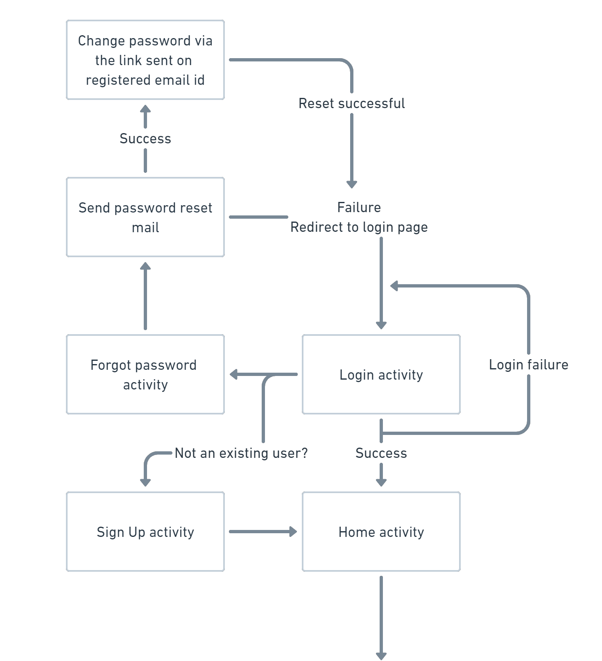

Figure 2: System Architecture (P1)

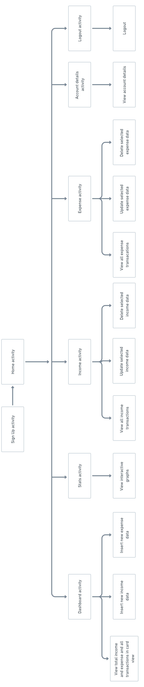

Figure 2: System Architecture (P2)

### Database Schema

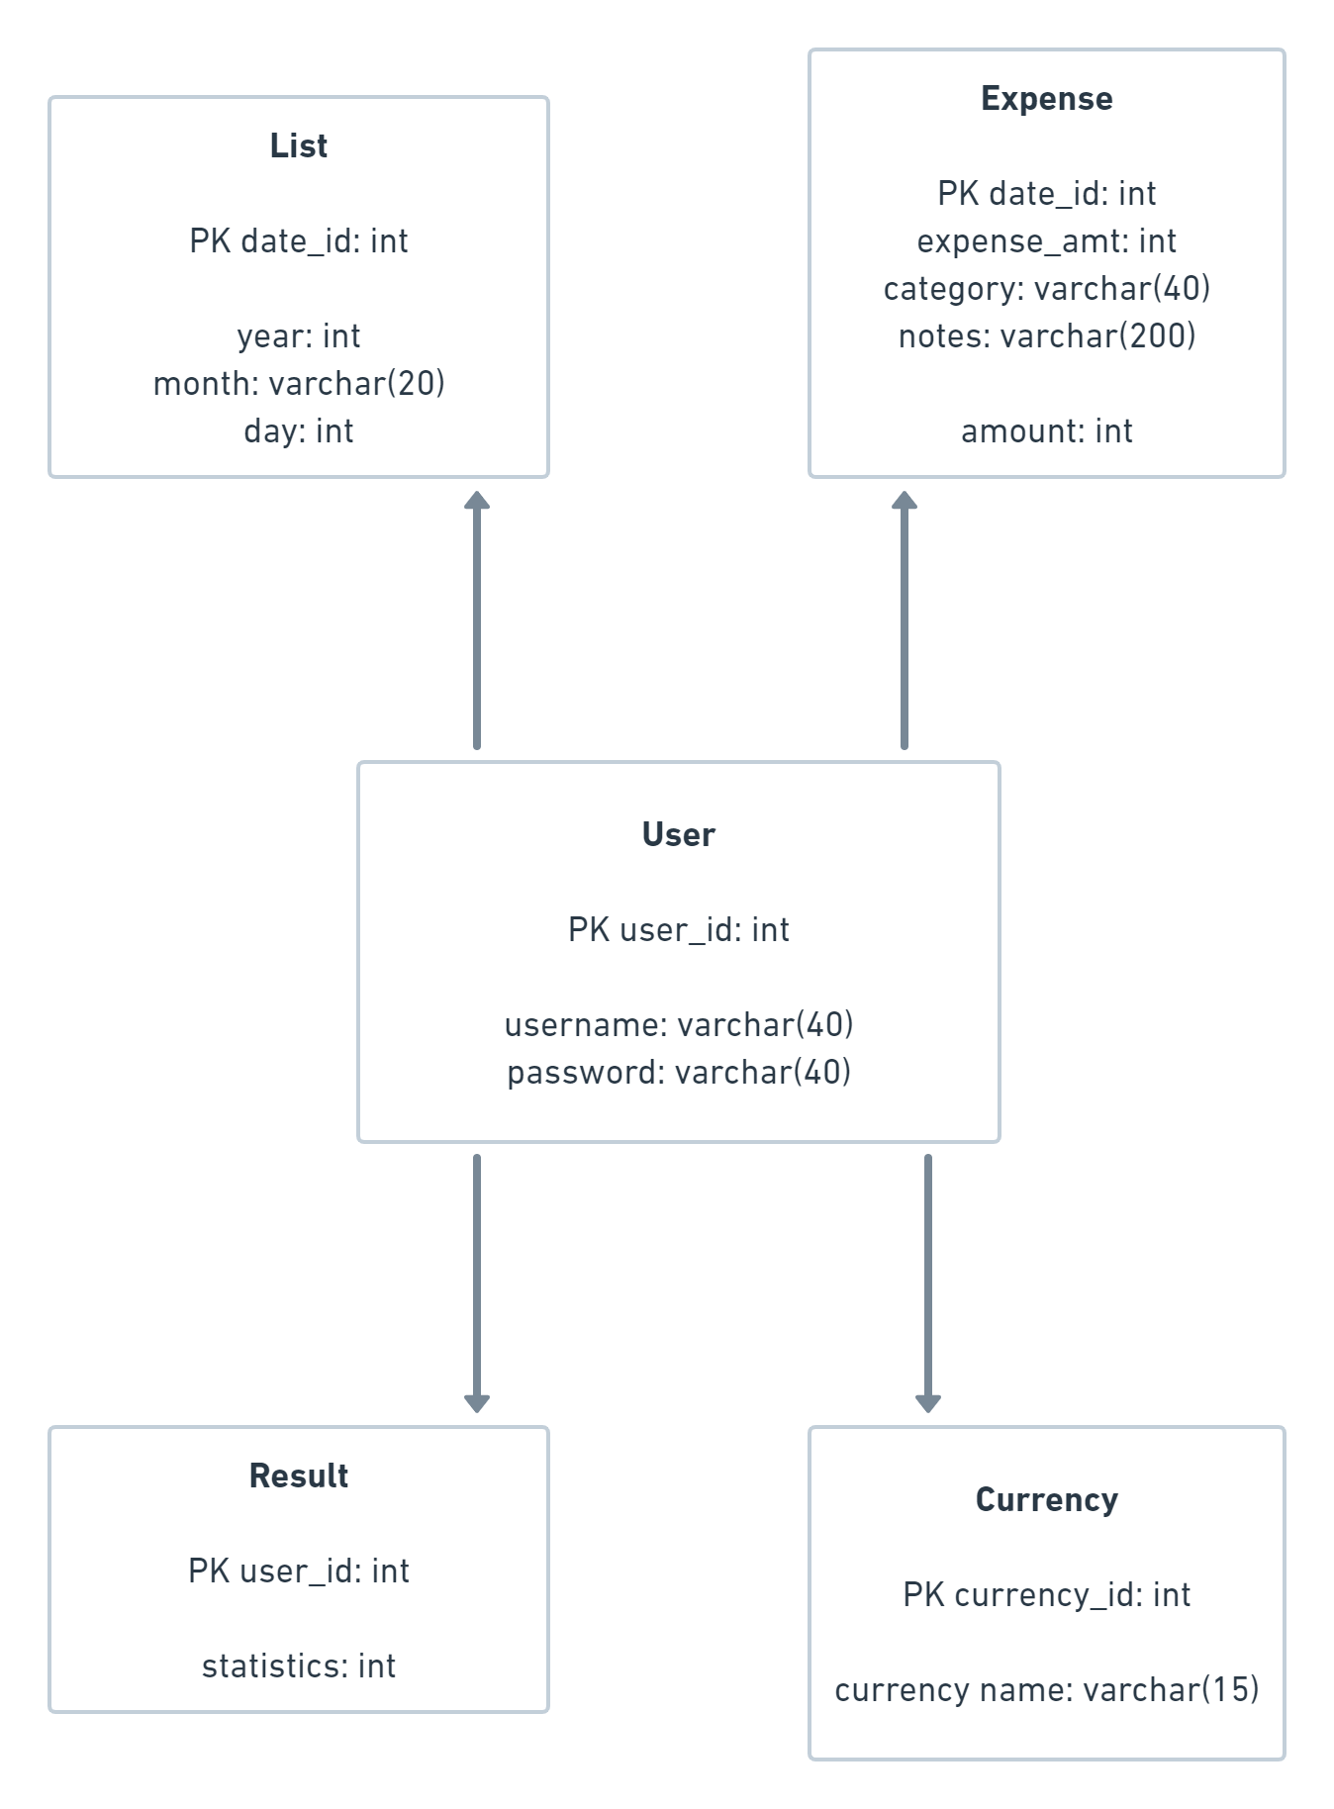

Figure 3: Database Schema

There are five tables in our application database which are user, expense, result, income and daily list. In above diagram the tables covers their respective primary key and their fields.

### Data Dictionary

A data dictionary also known as metadata repository is a centralized repository of information such as meaning, relationship to other data, origin, usage and format.

*Table 2: Data Dictionary*

|  |  |  |  |  |
| --- | --- | --- | --- | --- |
| S. No. | Entity | Attribute | Data Type | Constraints |
| 1 | Date User | user_id  username  password | int  varchar(20)  varchar(20) | Primary |
| 2 | Date list | date_id  year  month  day | int  int  int  int | Primary |
| 3 | Expense | date_id  exp_id  expense category  expense notes | int  int  varchar(20)  varchar(20) | Foreign  Primary |
| 4 | Result | Statistics | long int |  |

## ER DIAGRAM

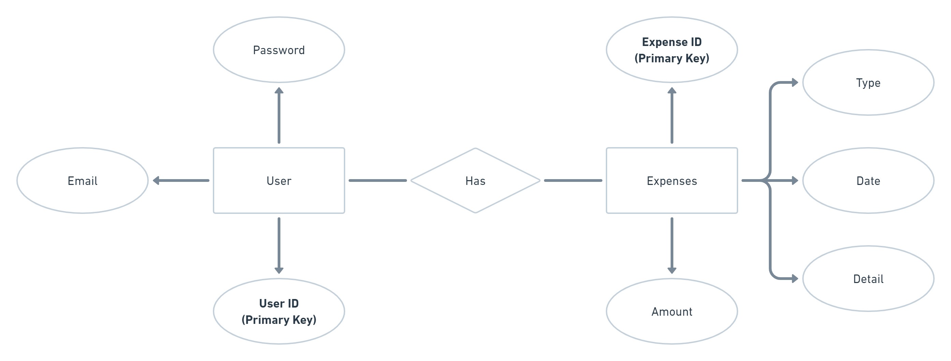

Figure 4: ER Diagram

The above diagram explains the relationship between the databases where rectangle represents entity, oval represents attributes and diamond represents relation. There are four entities with their respective attributes.

# Chapter 4

# Tools, Testing and Results

## Front End Tools

XML: Extensible Markup Language is part of the family of XML markup languages. It mirrors or extends versions of the widely used Hypertext Markup Language, the language in which Web pages are formulated. XML is used to design the UI in android platform for the ease of the user.

## Back End Tools

JAVA: Java is a general-purpose computer-programming language that is concurrent, class-based, object-oriented, and specifically designed to have as few implementation dependencies as possible. As the back end tools java is used to provide functionality to the attributes displaying in UI.

## Module Description

A modularization consists of well-defined manageable units with well-defined interfaces among the units. Desirable property of modular system include:

1. Each module is a well-defined sub-system.
2. Single, well - defined purpose of each module.
3. Modules can be separately compiled and stored in a library.
4. Modules should be easier to use than to build.
5. Modules should be simpler from outside then from inside.

The project can be decomposed in following modules:

1. Login module: This module is responsible for a registered user to login to the web application and do the proceedings.
2. Signup module: This module is responsible for registering a new user to the web application and create a new account for him/her.
3. Sessions module: This module is responsible for creating a session when a user logs in and continues till he/she logs out.
4. Add Bill: This module is responsible to enable the user to add a new bill
5. Delete the bill: This module is responsible for the pre-defined bill.
6. View Expense: This module is responsible for viewing all the expenses in detail added to the log by a logged in user.
7. Edit Module: This module is responsible for editing a pre-defined bill.
8. Categories module: This module is responsible for various options. In this app users have options of selecting various basic expense categories and currency according to their country.
9. Add note and date: This module is responsible for adding notes and dates to the expenditure of user.

## Testing

Testing is the process of evaluation a software item to detect differences between given input and expected output. Testing is a process that should be done during the development process.

### Unit Testing

The Unit testing part of a testing methodology is the testing of individual software modules or components that make up an application or system.

*Table 3: Test Case for Installation*

|  |  |  |  |  |  |  |
| --- | --- | --- | --- | --- | --- | --- |
| S. No. | Test Case Id | Test Description | Input Test Data | Expected Result | Actual Result | Remarks |
| 1 | TC-INS-01 | Install ETS app in android phone | Transfer ETS app | Open application with its home page | Application executed with home page | Pass |

*Table 4: Test Case for Login*

|  |  |  |  |  |  |  |
| --- | --- | --- | --- | --- | --- | --- |
| S. No. | Test Case Id | Test Description | Input Test Data | Expected Result | Actual Result | Remarks |
| 1 | TC-LG-01 | Enter valid data in username and password field | rashna  ***** | Show home page for user Rashna | Displayed home page for user Rashna | Pass |
| 2 | TC-LG-02 | Enter valid data in username and leave password field empty | rashna | Show error | Didn’t show any error | Fail |
| 3 | TC-LG-03 | Leave username and password field empty and press login | ***** | Show error | Printed “Enter username” | Pass |
| 4 | TC-LG-04 | Enter invalid username and password | rashana  ***** | Show error | Printed “You are not registered | Pass |

*Table 5: Test Case for Data Entry*

|  |  |  |  |  |  |  |
| --- | --- | --- | --- | --- | --- | --- |
| S. No. | Test Case Id | Test Description | Input test data | Expected Result | Actual Result | Remarks |
| 1 | TC-DT-01 | Enter expense values with their category | 1500 with category clothing | Update category table with value 1000 | Updated category table with value 1000 | Pass |
| 2 | TC-DT-02 | Enter non-numeric for expense field | Rashna | Show error | Printed “Enter valid value” | Pass |
| 3 | TC-DT-03 | Enter decimal value for expense field | 155.65 with category food | Update category table with value 155.65 | Updated  category table with value 155.65 | Pass |
| 4 | TC-DT-04 | Enter negative value for expense field | -2635 with category rent | Update category table with value -2635 | Updated category table with value -2635 | Fail |
| 5 | TC-DT-05 | Enter expense values without any category | 1860 | Update default category others with value 1860 | Cannot update table | Fail |
| 6 | TC-DT-06 | Enter future date for expense | 2022/12/10 | Show error in entering future expense | Updated table with future date | Fail |

### System Testing

The system testing part of a testing methodology involves testing the entire system for errors and bugs. This test is carried out by interfacing the hardware and software components of the entire system, and then testing it as a whole.

*Table 6: System Testing*

|  |  |  |  |  |  |  |
| --- | --- | --- | --- | --- | --- | --- |
| S. No. | Test Case Id | Test Description | Input test data | Expected Result | Actual Result | Remarks |
| 1 | TC-INS-01 | Install ETS app in android phone | Transfer ETS app | Open application with its home page | Application executed with home page | Pass |
| 2 | TC-LG-01 | Enter valid in user name and password field | Rashna  ***** | Show home page user Rashna | Displayed home page for user Rashna | Pass |
| 3 | TC-DT-05 | Enter expense without any category | 1860 | Update default category others with value 1860 | Updated category others with value 1860 | Pass |
| 4 | TC-CL-01 | Go to chart page which shows the data in pie format | Click account tab | Show the chart of all the expenses of that day | Showed the chart of all the expenses of that day | Pass |

## Results

Output in sequential way:

1. Signing Up

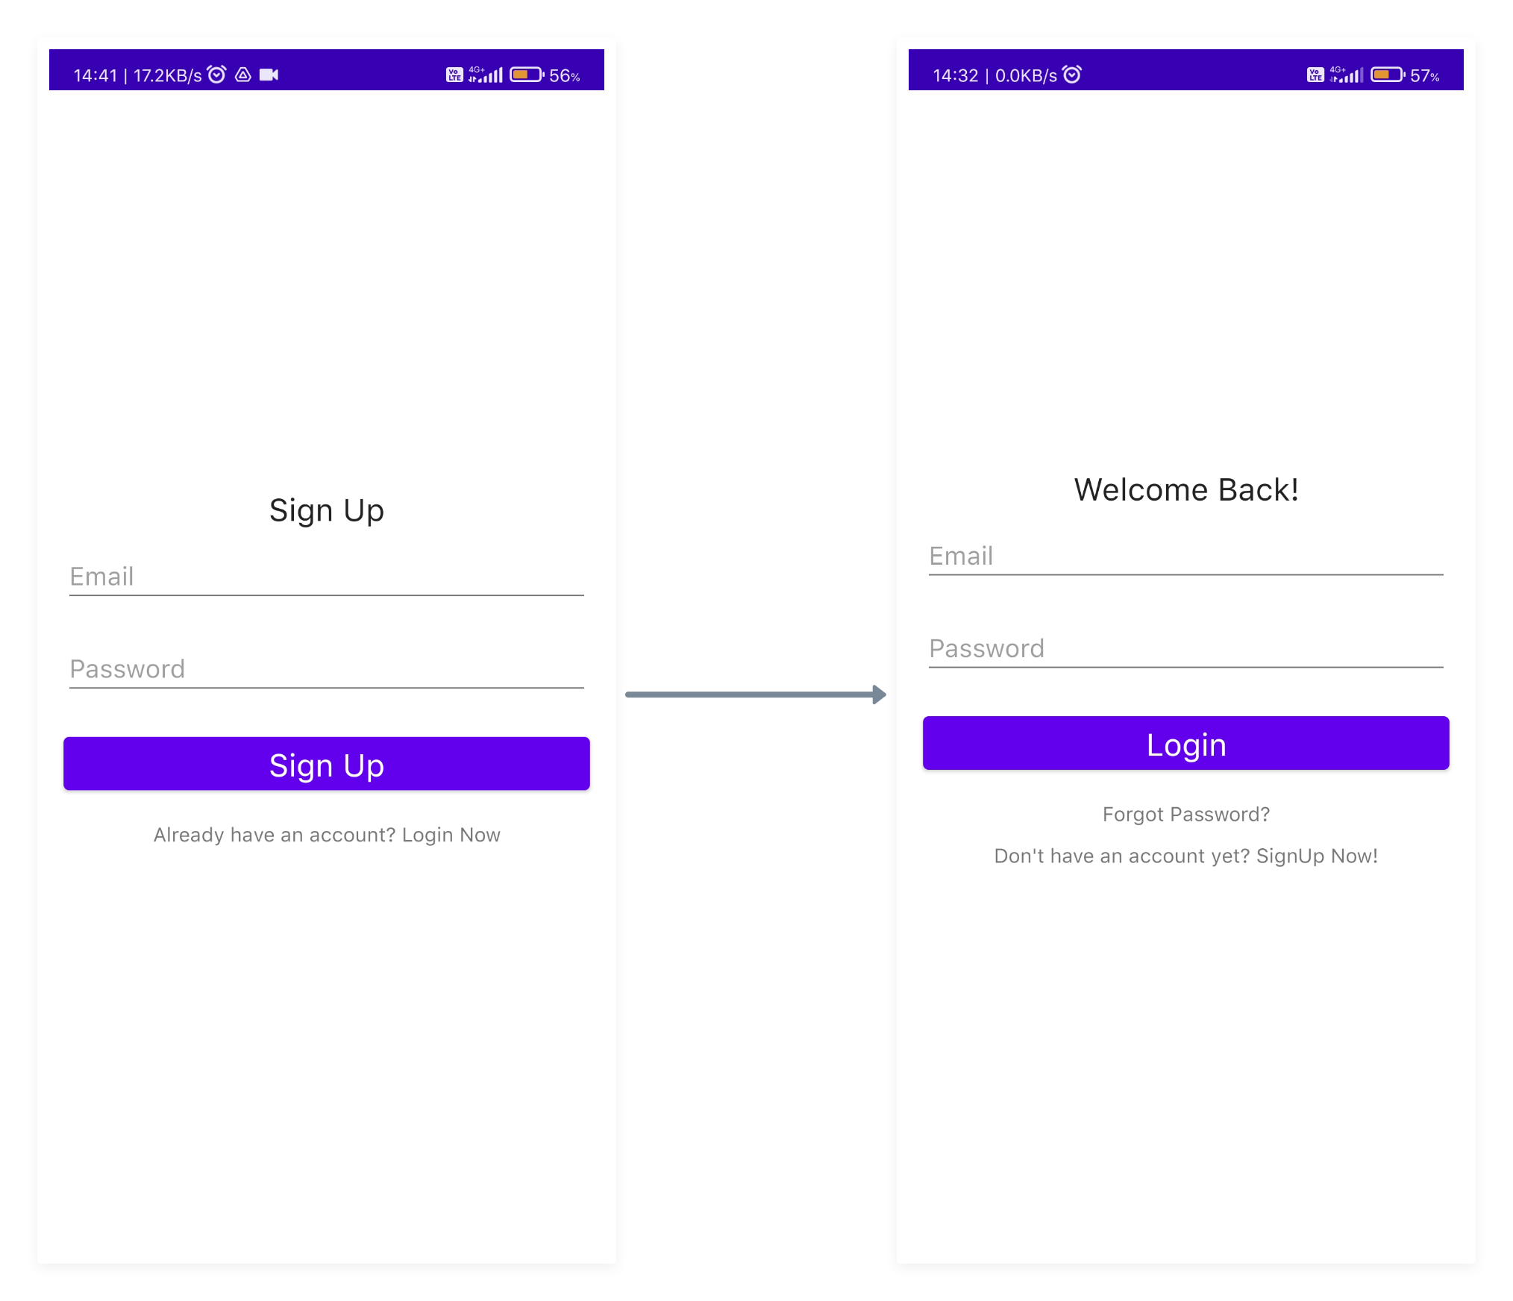

1. Reset Password

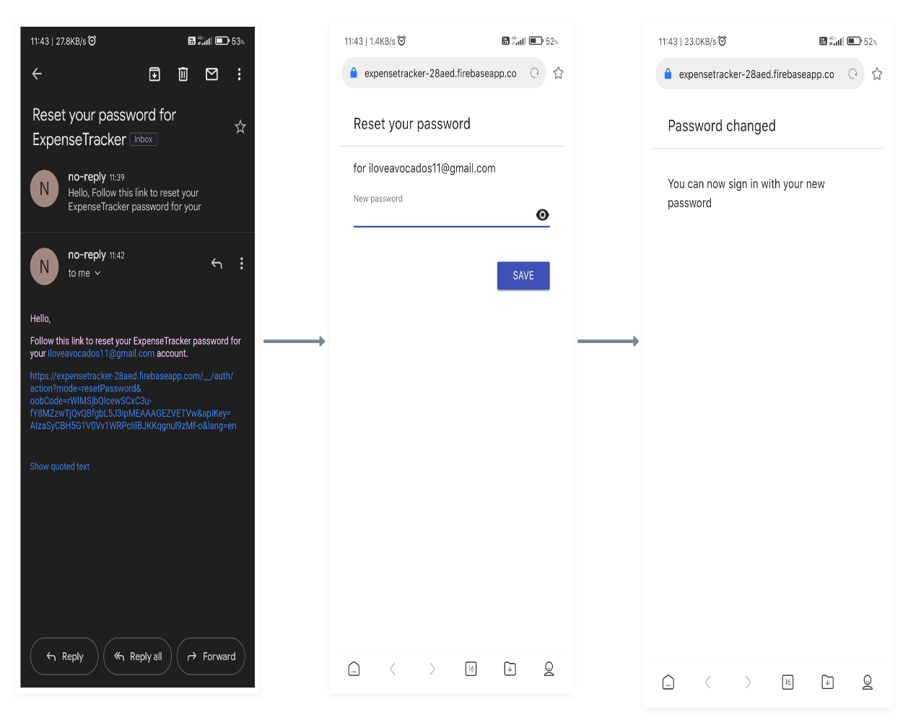

1. Signing Out

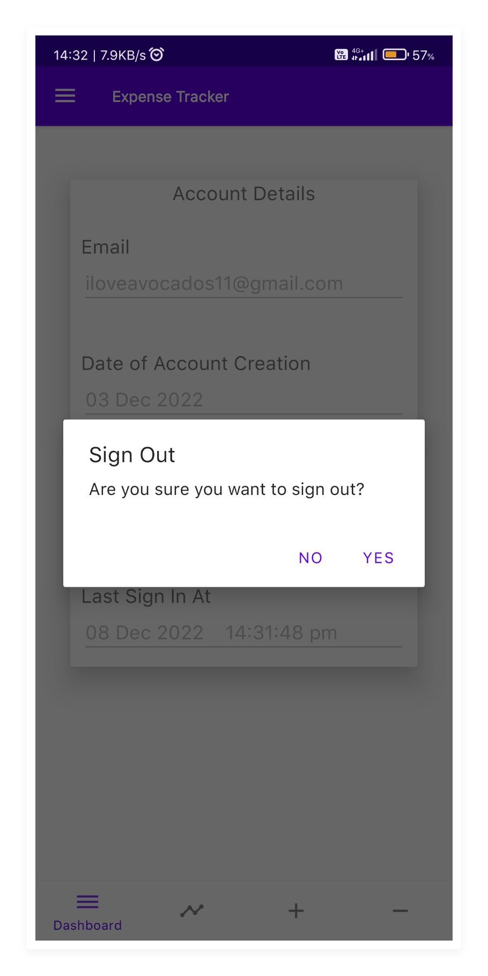

1. Navigation Bar

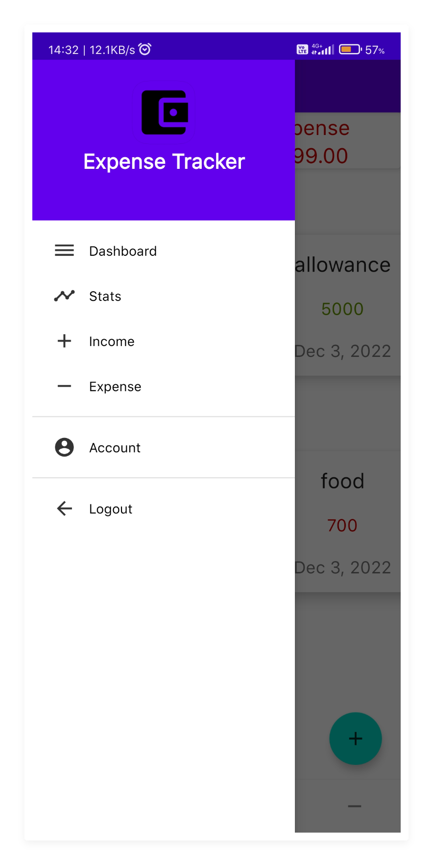

1. Account Details

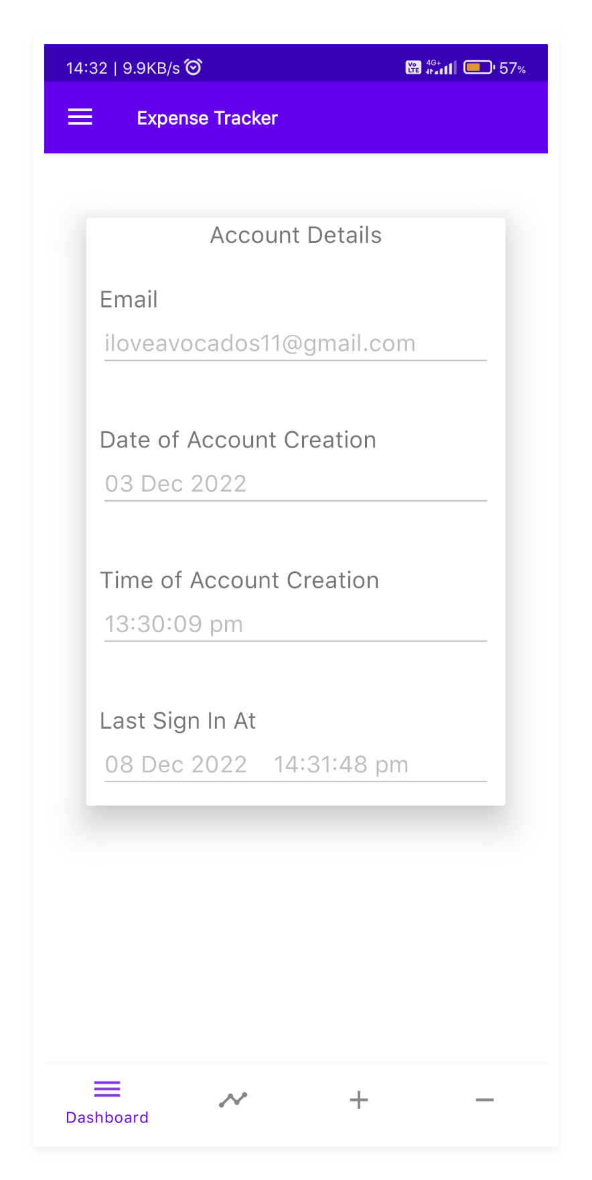

1. Dashboard

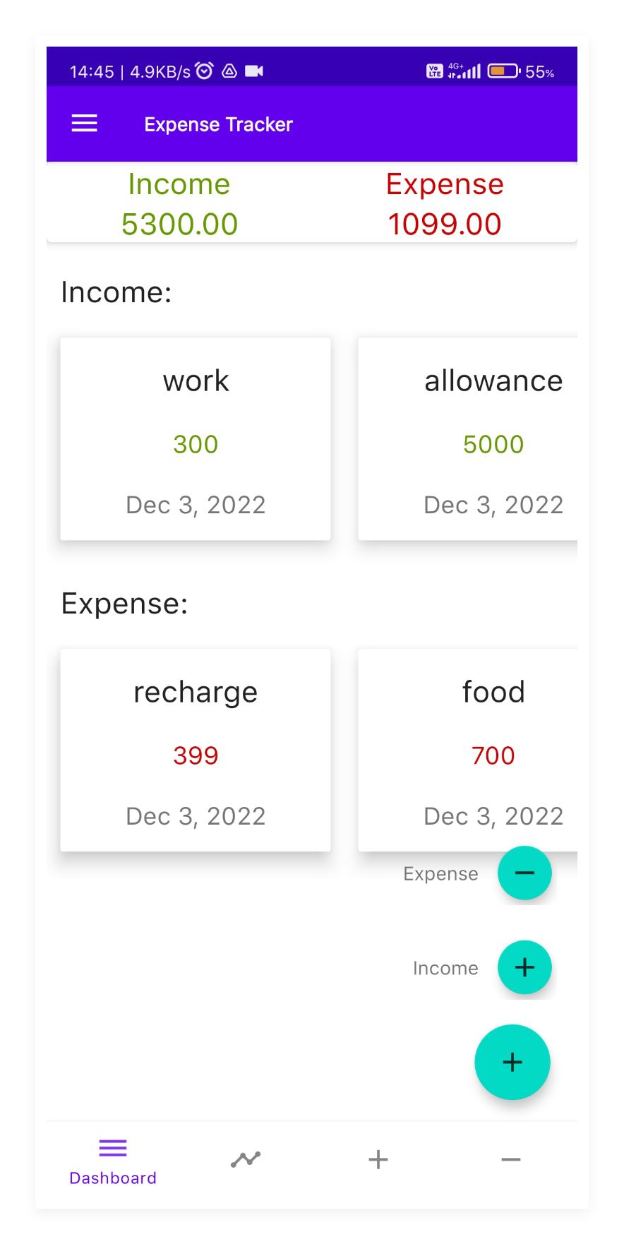

1. Adding

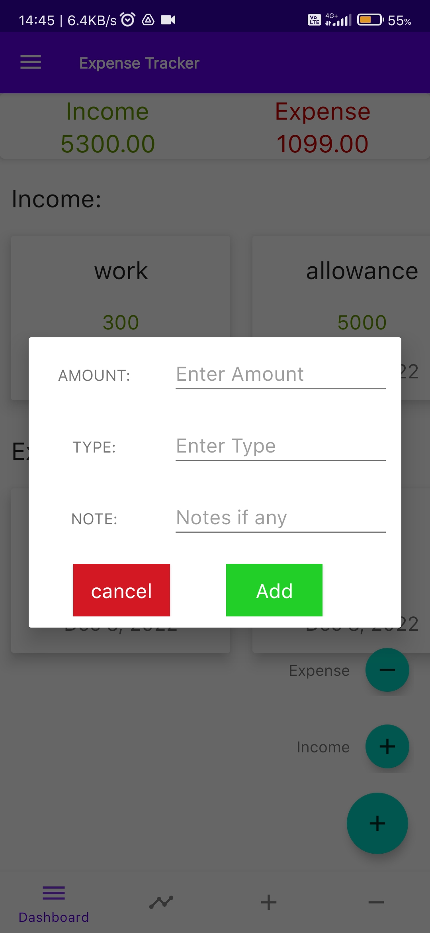

1. Updating

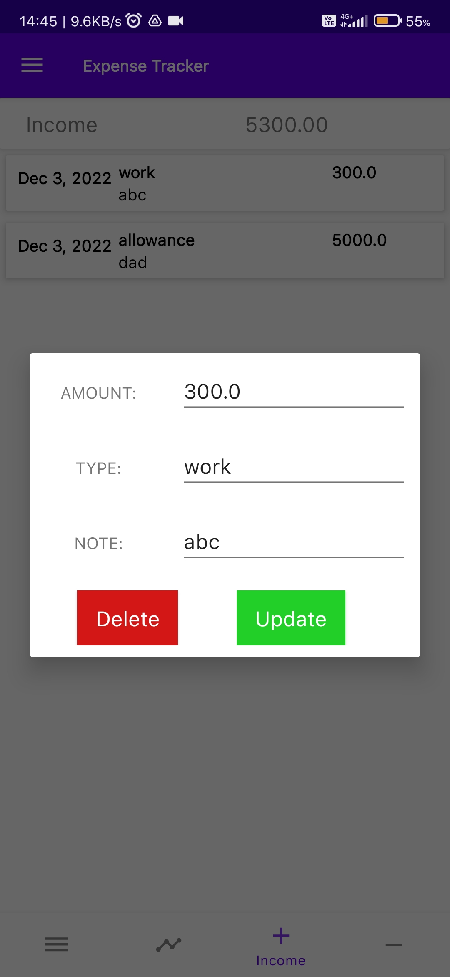

1. Income Report

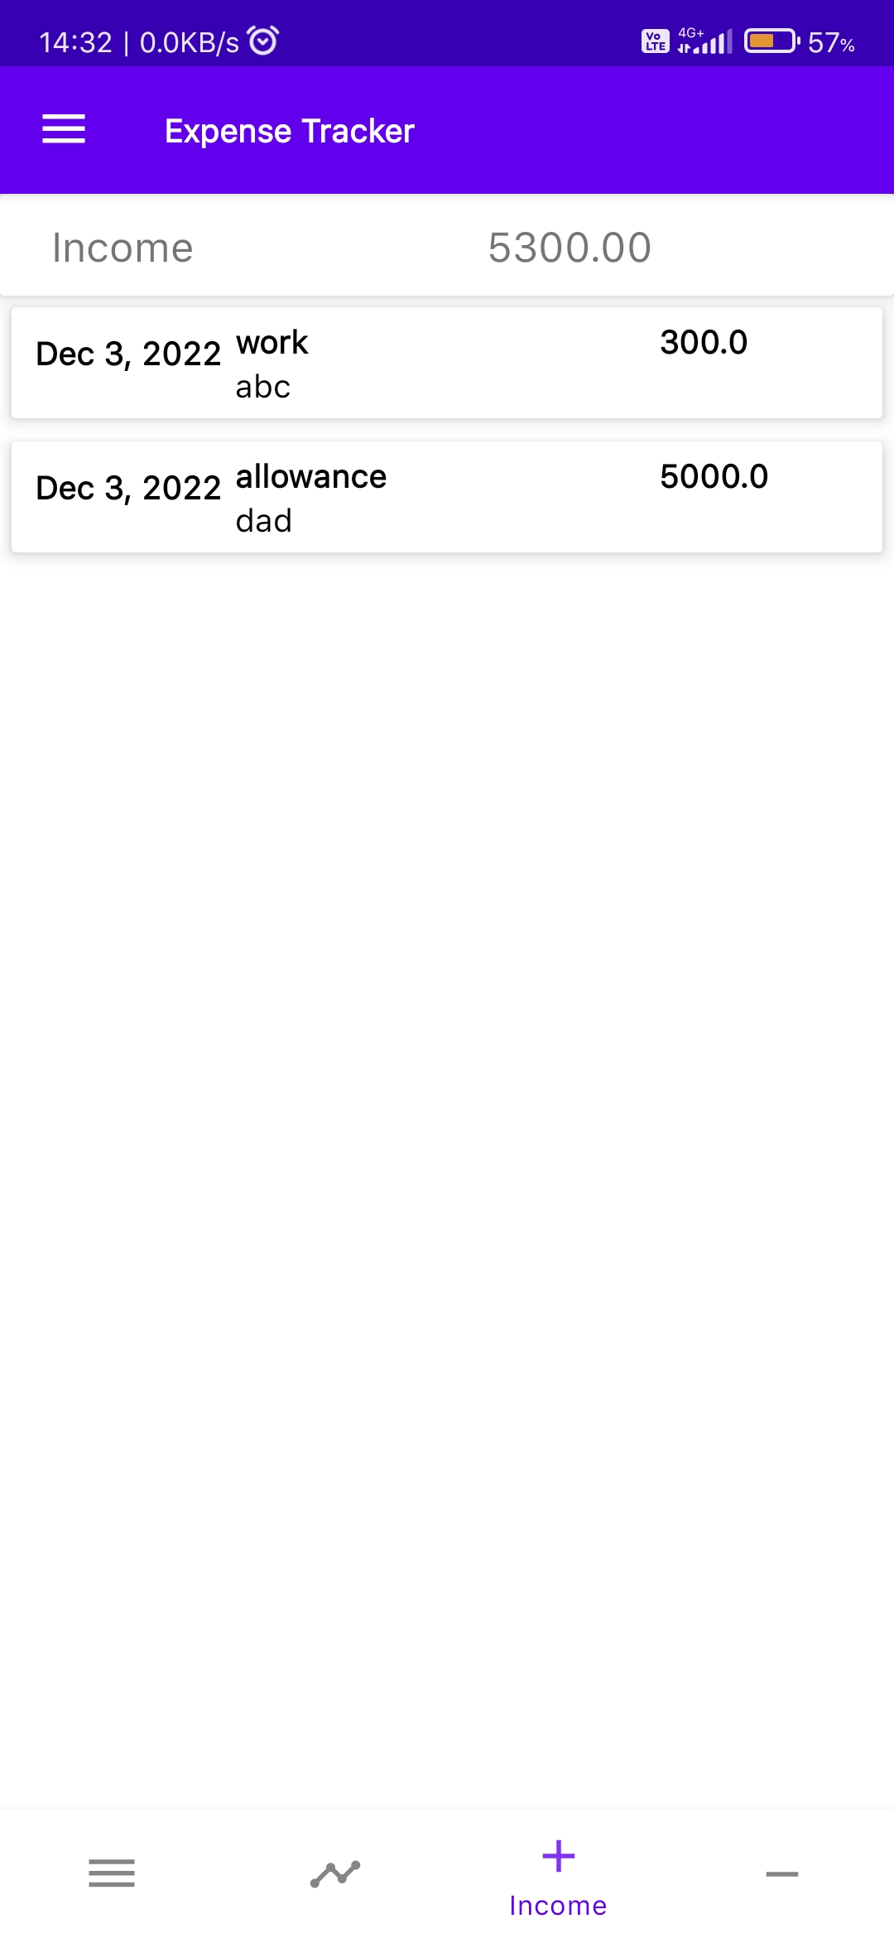

1. Expenditure Report

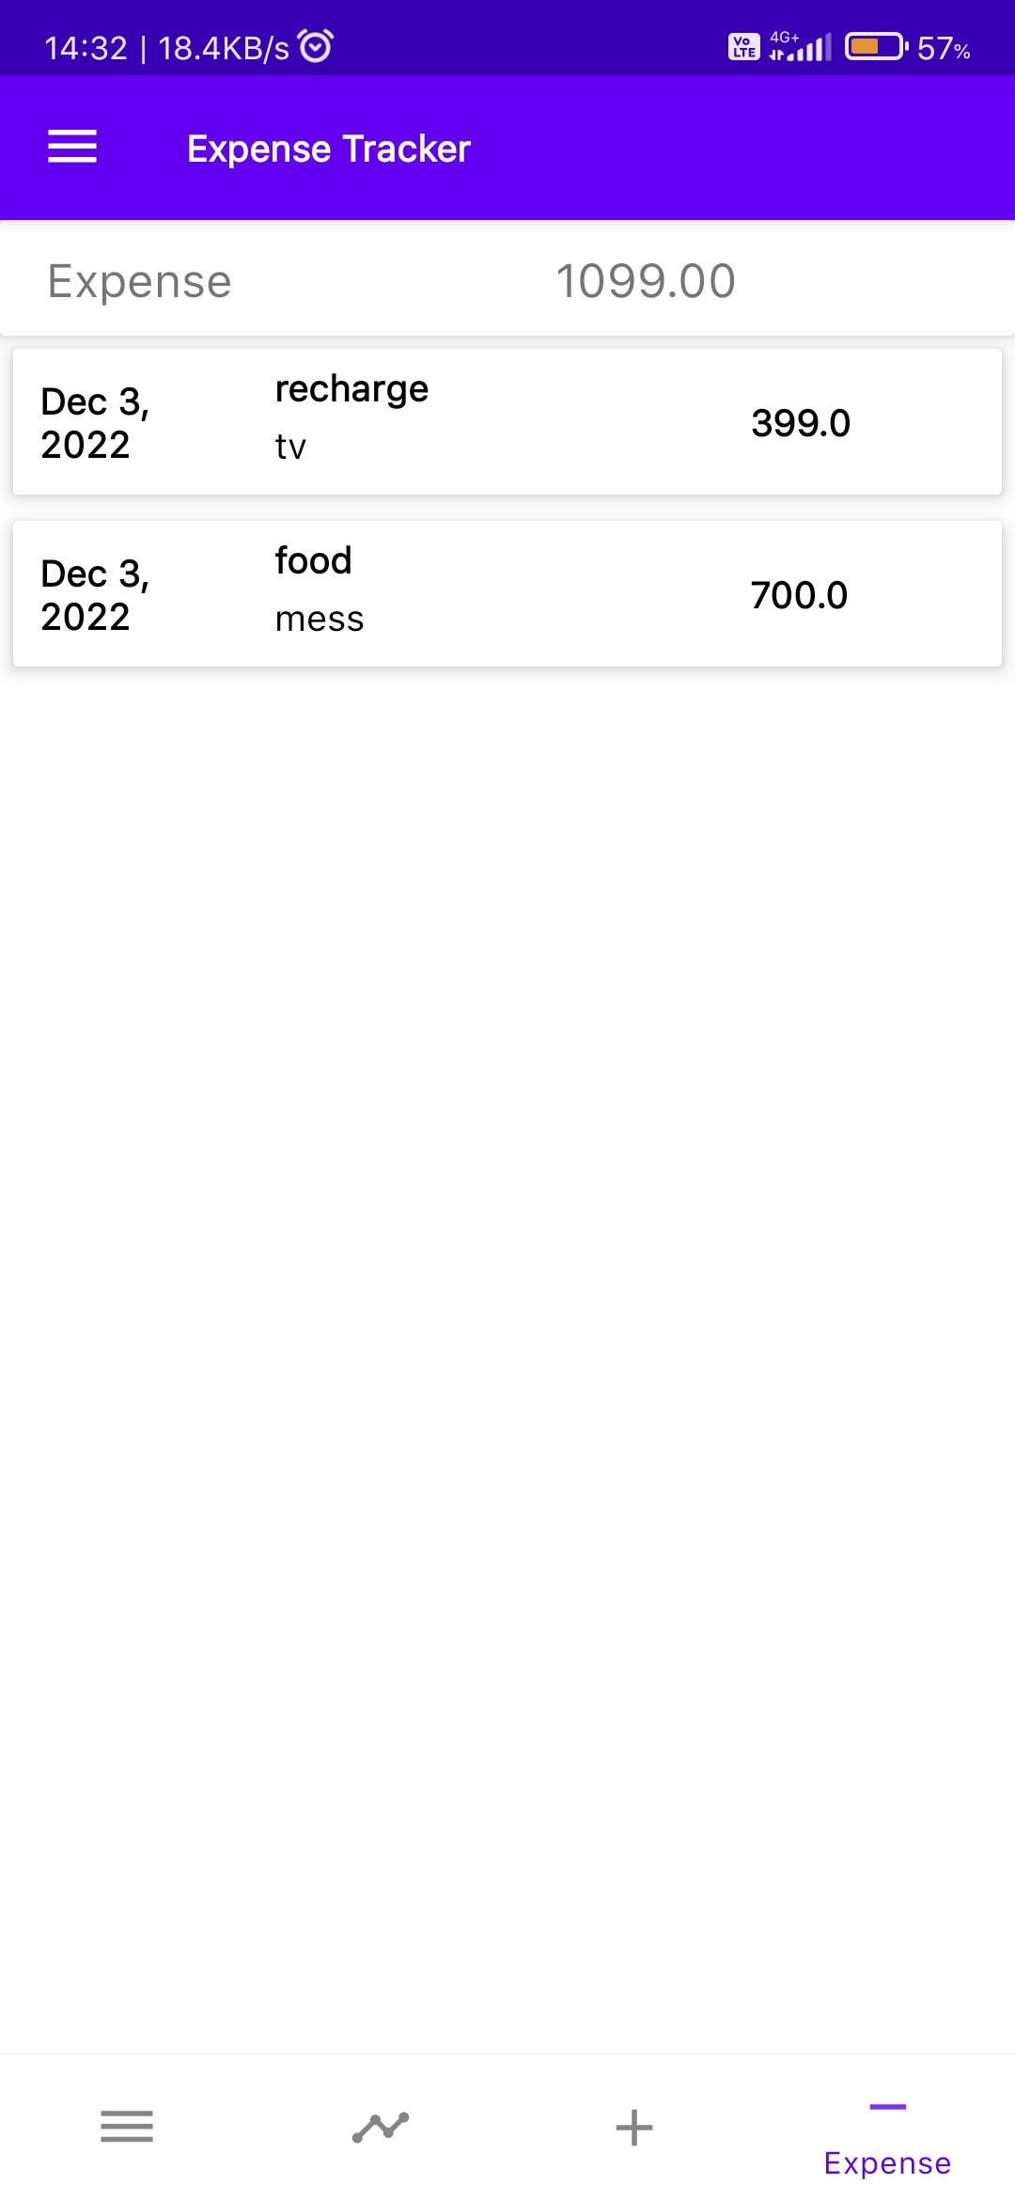

1. Pie Chart Analysis

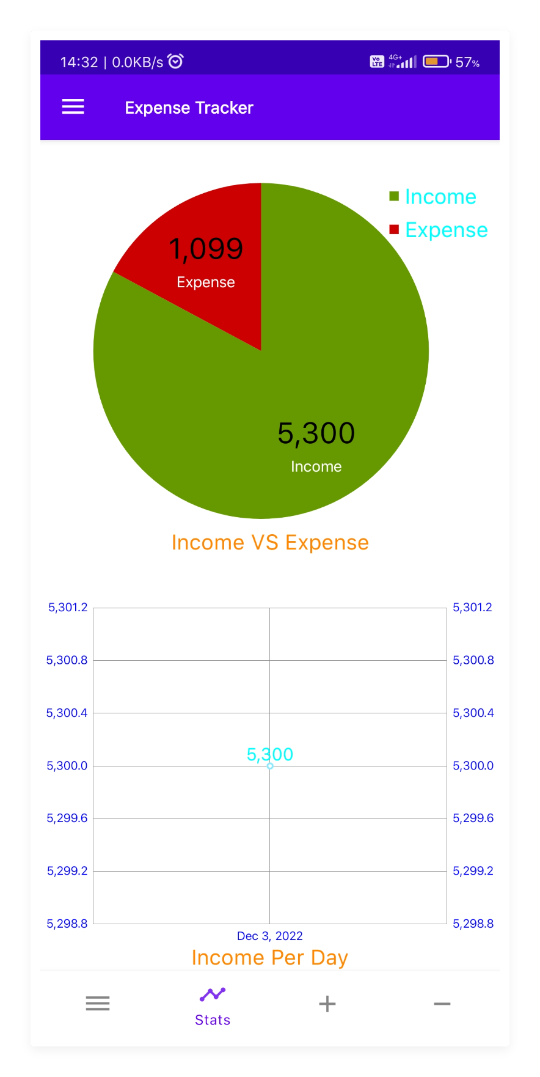

# Chapter 5

# Summary and Conclusion

## Summary and Achievements

1. An application to track and keep an eye on our spending.
2. Users can use this program easily as it will be compatible with the majority of devices Android is the most popular operating system for mobile and other tiny devices.
3. The user will provide his account information, which will initially be saved for additional program functionality.
4. The work plan is represented by the spiral model.
5. This model indicates that development will occur more than once as adjustments are made.
6. It provides a future extension.

## Conclusion

After making this application we assure that this application will help its users to manage the cost of their daily expenditure. It will guide them and aware them about their daily expenses. It will prove to be helpful for the people who are frustrated with their daily budget management, irritated because of amount of expenses and wishes to manage money and to preserve the record of their daily cost which may be useful to change their way of spending money. In short, this application will help its users to overcome the wastage of money.

## Future Scope

In further days, there will be AI and pay mode embedded with the app, Also, backup details will be recorded on cloud.

This application can take a good market as it is usable by anyone who are willing to manage their expenses and aiming to save for the future investments and many more. There is not any range criteria or any kind of profession or gender are focused.

## Limitations

* User have to entry every record manually.
* The Category divided may be blunder or messy.
* Person who is handling system must have some technical knowledge.

# References

1. En.wikipedia.org. (2018). Systems design. [online] Available at: https://en.wikipedia.org/wiki/Systems design [Accessed 2 May. 2018]
2. Slideshare.net. (2018). Android ppt with example of budget manager. [online] Available at: https://www.slideshare.net/nalinimehta73/android-ppt-with- example-of-budget-manager [Accessed 21 Apr. 2018].
3. Creately.com. (2018). Expense tracker. [online] Available at: https://creately.com/diagram/example/hv2esdz2/expense%20tracker [Accessed 25 Apr. 2018].
4. Introduction to Android: https://google-developer-training.github.io/android-developer-fundamentals-course-concepts-v2/unit-1-get-started/lesson-1-build-your-first-app/1-0-c-introduction-to-android/1-0-c-introduction-to-android.html
5. Android for developers: https://developer.android.com/
6. Android software development: https://en.m.wikipedia.org/wiki/Android software development

# Bibliography

[1] N. Mehta, "Android Application Expense Manager," 2014.

[2] A. Bamne, "expense tracker (Class Diagram (UML)," 2014.